## horizontal line

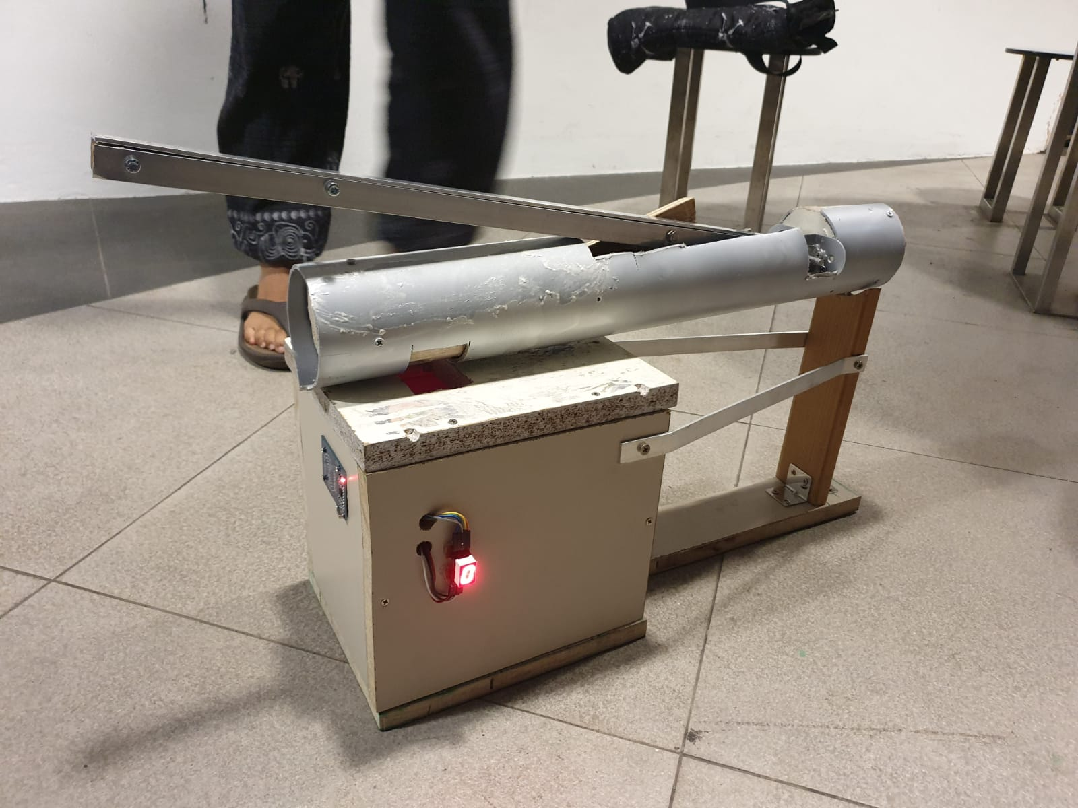

Can-queror

09.04.20XX

**─**

Farris - Virgil - Hans

Singapore Polytechnic

Engineering Academy CA3 - Report

**Background** **2**

**Problem Statement** **2**

**Existing Solution** **3**

**Solution** **3**

**Prototype** **4**

Chassis 4

Electronics 7

Program 9

Edge-code 9

Back-end 10

**Testing** **11**

**Conclusion** **11**

**Reference** **12**

# 

# 

# 

# Background

Aluminum cans, aka “tin can” started proliferating during the 1957. It was light, clean and relatively cheap to mass produce. Today, there are 180 billion cans produces globally and one of its uses it to hold beverages from the gassy Coca-cola to Japan’s self-heating coffee. All around the world, aluminium cans are used and it has become the most recyclable material of them all. However, Singaporeans are not recycling aluminium cans. These cans are either thrown away without being recycled or are placed around stores as litter. Thus, in this report, we will look at the problem and the solution we come up with.

# Problem Statement

Before we can tackle the problem of Aluminium cans not being recycled. We first need to find out why they are not recycled. An article called “Why People Don’t Recycle” did a survey to find out why people do not recycle and found out the top two greatest reason for not recycling is that it is not accessible or convenient to where I live and it takes up too much time (Schumaker, 2016).

We also noticed that there are more cans that are littered in mini market such as 7/11. Most of these littered cans are does by students who visited the store and could not be bothered to even throw is away. We also found cans around our school just left on the ledges of the building or railways. From this, we concluded that most of the cans that are not being recycled, or even being thrown away properly are done by students.

Thus we have come up with the problem statement on how can we encourage students to recycle aluminium cans in Singapore.

# 

# Existing Solution

Some existing solutions used are simply to place a recycling bin in each school for the users to place their recycling trash. However, this method is subjected to users dumping items that are not recyclable and are contaminated. This in return will cause the contents of the bins to be thrown away ,whole, due to the difficulty of separating the waste and contaminants from it. Thus, the cans will not be recycled efficiently.

# Solution

Our solution is to make a dedicated recycling bin for aluminium cans which also gives back some reward to the users. Since our bins are specifically designed for aluminium cans, it is most definitely likely to only have aluminum cans inside the compartment. Not only that, users will be encouraged to recycle as they can top up their ezlink cards with the cashback system. Ezlink cards have many users, such as to pay to go up an mrt, or to buy stuff at 7-eleven , thus we feel it is a good medium for cash storage and transfer.

# 

# 

# 

# 

# 

# Prototype

## Chassis

In this project, we require a crushing mechanism and a storage system to crush and store our cans. So, we used linkages to transmit rotational force into linear force, utilizing moment to easily crush a can.

Materials used are: Unused IKEA shelving wood,Flat aluminium bar 3mm x 600mm, L aluminium bar 3mm x 600mm, 6 steel brackets, PVC pipe of around 1metre , hex bolt screws and nuts and wood screws.

Here are a few photos to demonstrate our idea.

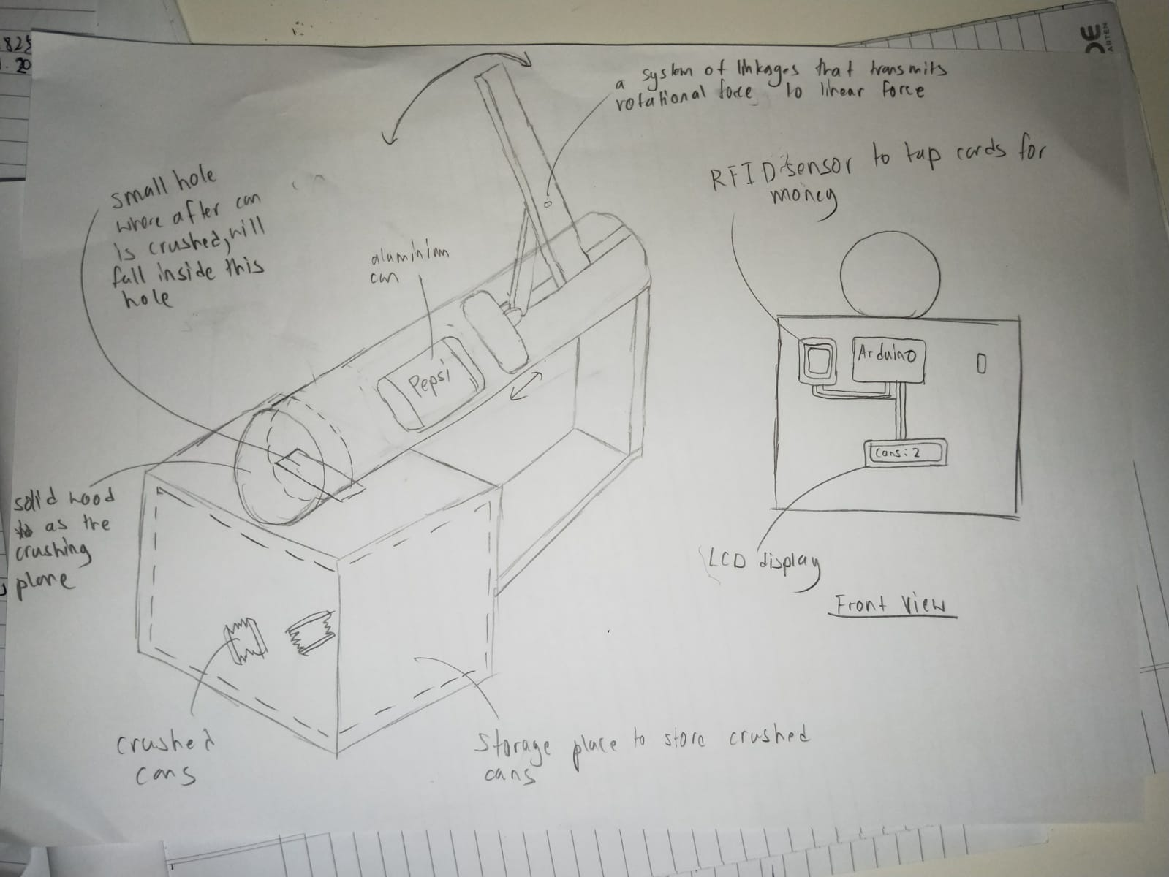

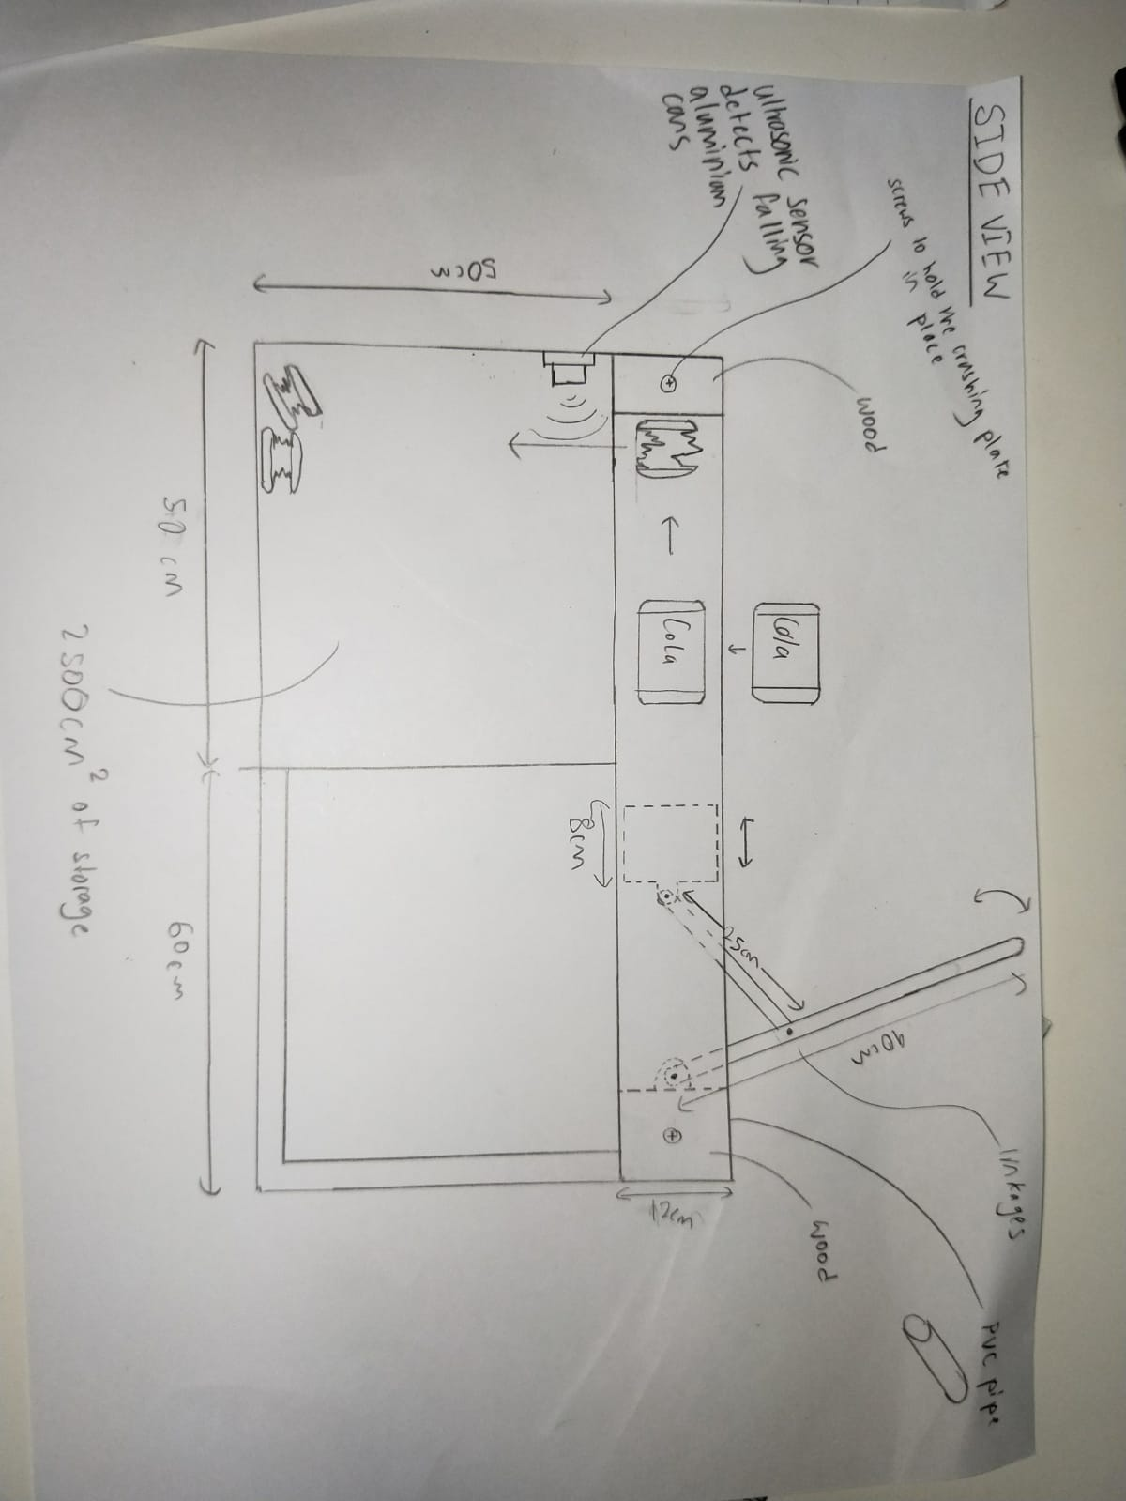

Some problems we faced was the lever the user pushes to crush the can required too much force to crush the can. What we did to resolve this was to simply increase the length of the lever so that using the principle of moment, less effort is needed to crush the can.

General dimensions and view of crushing mechanism:

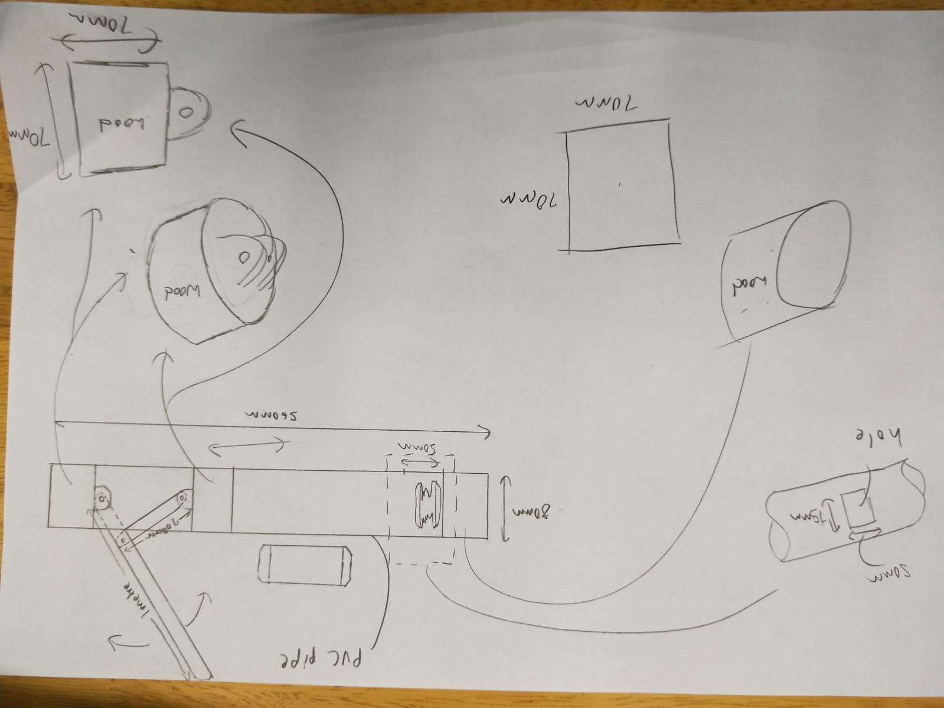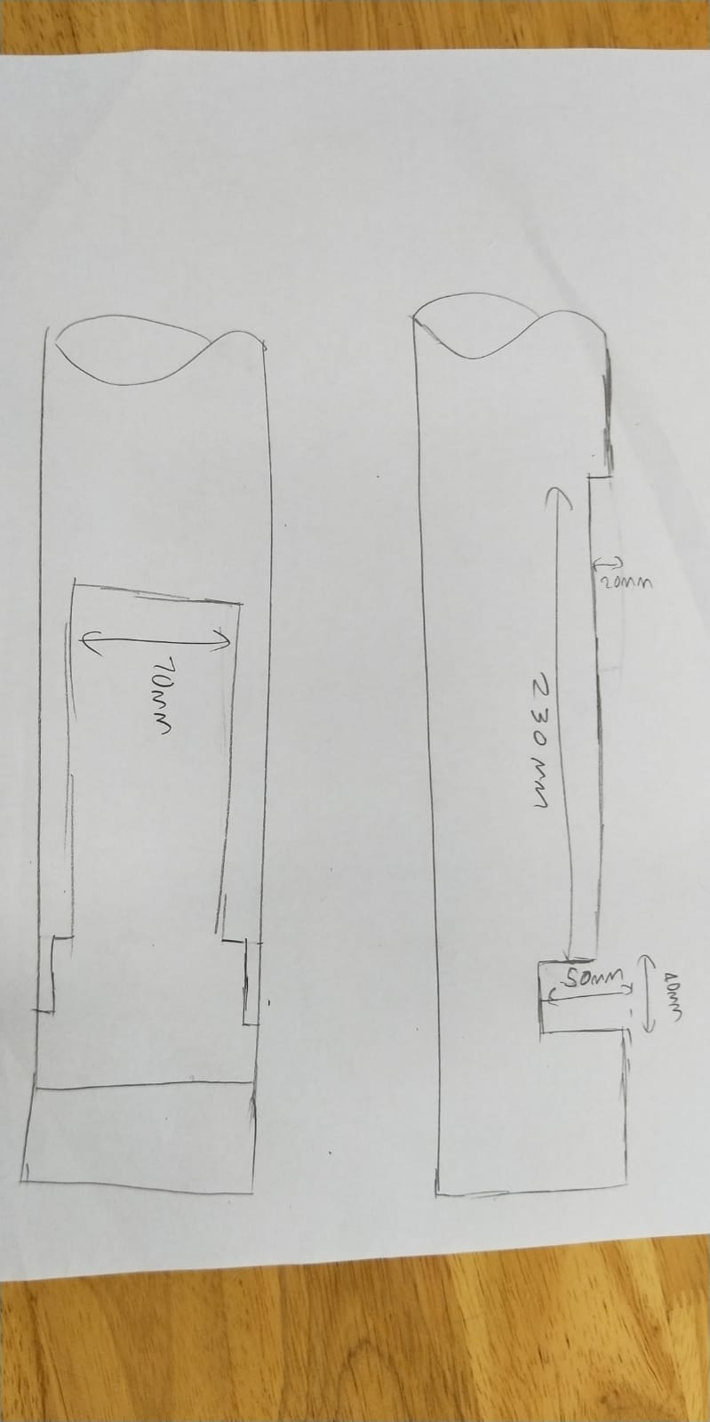

FINAL CHASSIS VIEW

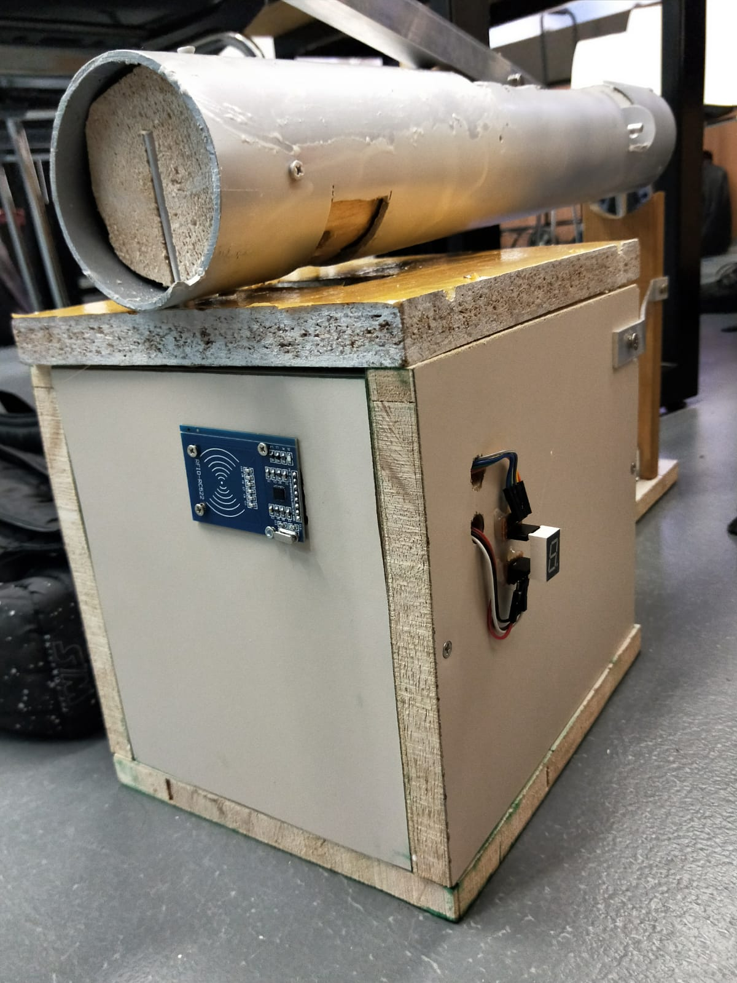

## Electronics

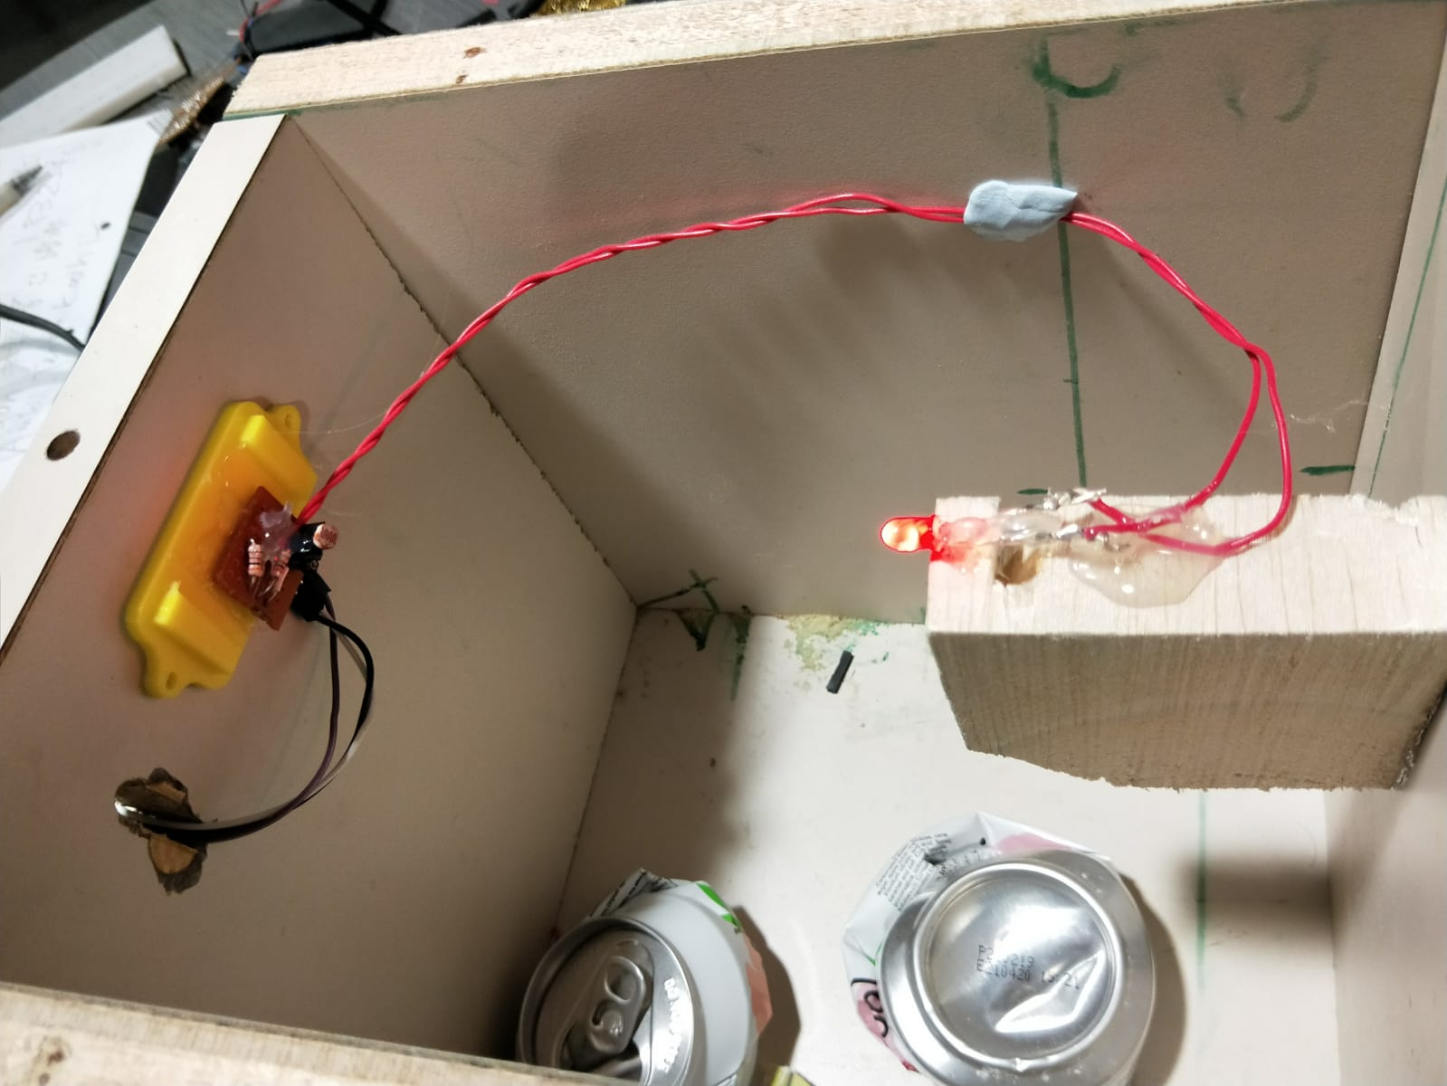

For the electronics, the Can-queror uses the following items:

1. 1x Esp32 DevkitC
2. 1x LED
3. 1x LDR
4. 1x 7 segment LED display
5. 1x RFID reader - MFRC55
6. 2x 330ohm resistor

The Esp32 is used as a microcontroller to control the whole program and send the appropriate MQTT messages to the cloud.

RFID reader to read the UID of the user’s EZ-link card so as to log their credentials and link it to the amount of cans they recycled.

7 segment LED display to display the number of cans recycled during a session.

The LED and LDR works together to count the number of cans that dropped into the Can-queror. Here is the schematic diagram of the LED and LDR paring.

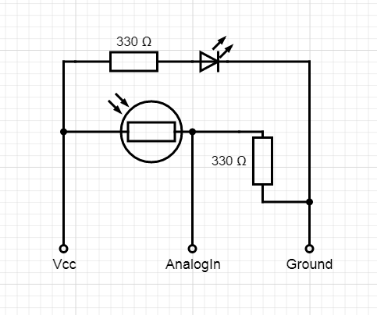

## 

## Program

### Edge-code

For the code that is loaded to the ESP32 we need it to be able to connect to the Internet, count the amount of cans being recycled, read the UID of the ezlink card and send the appropriate MQTT messages.

Here is the flowchart of the program:

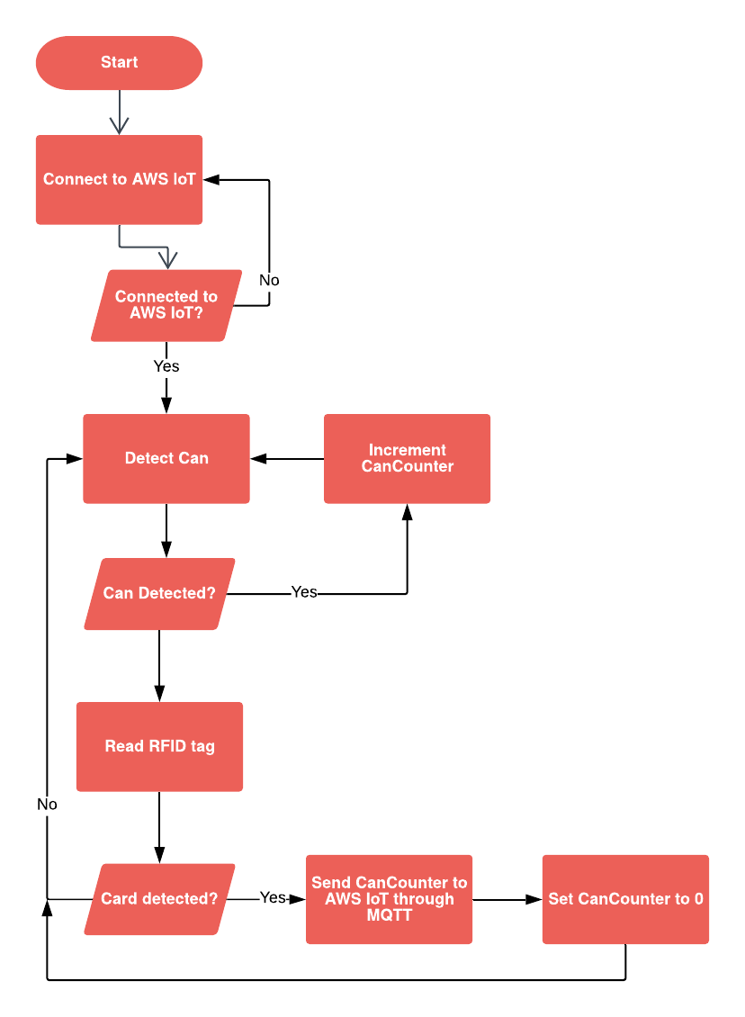

### 

### Back-end

For the back-end of our system, we have chosen to host everything with AWS under the free-tier. Here is how the architecture looks like:

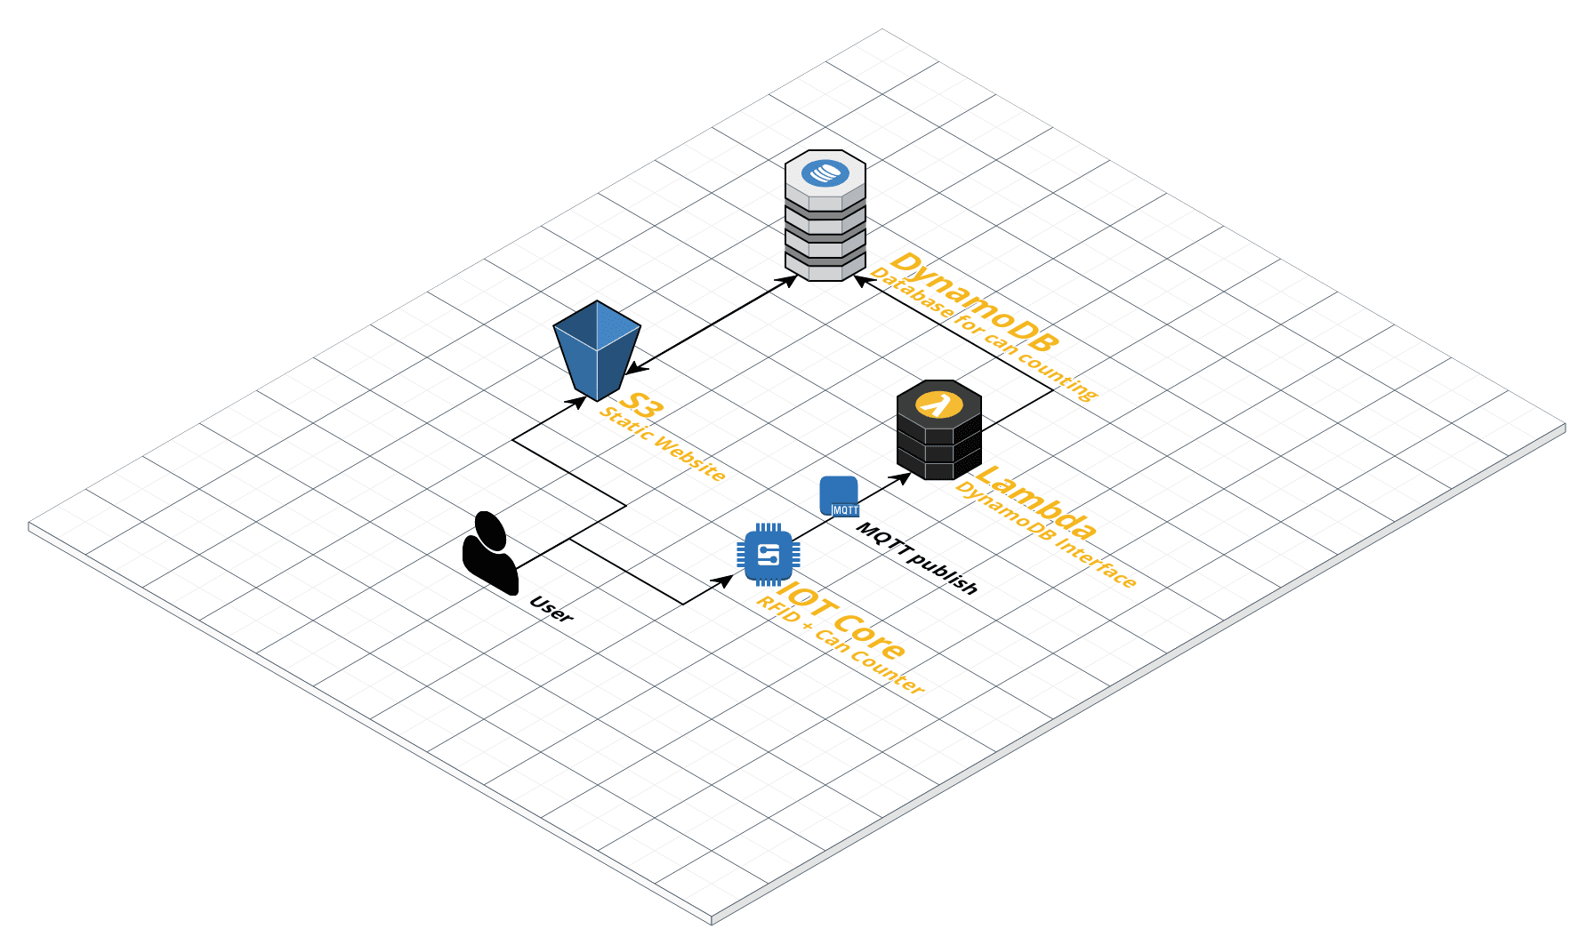

Our Can-queror will sent a MQTT message to AWS IoT once it has finished its session and this message will trigger a Lambda function to update the DynamoDB database. The database can be accessed through a static webpage that is hosted on S3.

# Testing

As we began testing our prototype, we had to analyse the functionality of our product and link the electrical components together. We had to ensure everything was working correctly and accurately. When our parts either broke or failed to function, we have to improvise, considering they failed at the last minute. While it seemed like the situation was nearly hopeless, we still thought of ways to improvise, such as changing the type of sensors and components. EA has taught us the spirit of resilience and perseverance, as we did not give up even when certain parts malfunctioned at the last minute.

We decided that we would replace our LCD with a 7-segment display for demonstration purposes to show ready state as well as number of cans. The ultrasonic sensor was replaced by an LED with light sensor as during testing it wasn't accurate and only sometimes worked. After testing, we found that it was working.

# Conclusion

The aim of this project is to come up with a model that will positively impact society, as part of the Tan Kah Kee Young Inventors’ Award nomination. Through this, we have learnt how engineering can benefit society.

As EA students, we also learnt the importance of not giving up and persevering when obstacles come our way. A perfect example of when this happened was when we found out some of our components were damaged, so we looked for ways to improvise. We also tested our model until it was working and functional.

Demo link:

https://youtu.be/IWuKvxaBQ-Y

# 

# Reference

Schumaker, E. (2016). *The Psychology Behind Why People Don't Recycle*. [online] Huffpost.com. Available at: https://www.huffpost.com/entry/psychology-of-why-people-dont-recycle_n_57697a7be4b087b70be605b3 [Accessed 12 Aug. 2019].

Wikipedia (2019). *Aluminium can.* [online] Wikipedia.org.

Available at:

<https://en.wikipedia.org/wiki/Aluminum_can> [Accessed 12 Aug. 2019]